DATA SCIENCE- API FOR DATA STREAMING

# COINAPI.IO FUNDAMENTALS

## SETUP

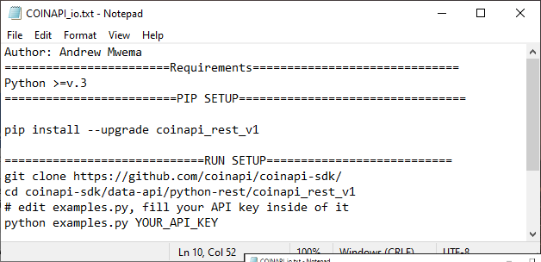

## GIT-BASH COMMANDS

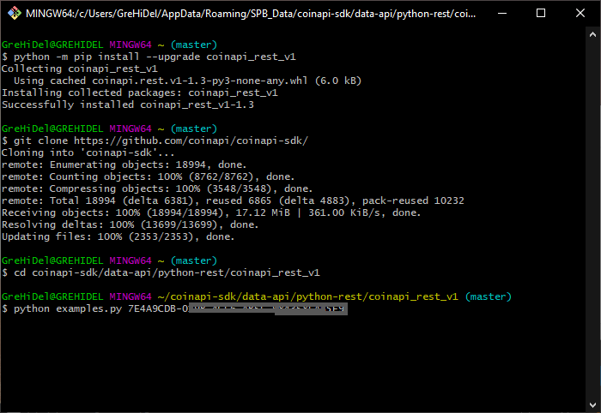

In Guaranteed.